5G/6G- COMMUNICATION SYSTEM
NAME: Allu Thanmai
REG .NO : 192412616
SLOT A

Ex.No.5: MIMO System Simulation with BER Analysis Date

AIM:To simulate a MIMO (Multiple Input Multiple Output) wireless communication system and analyze its performance in terms of Bit Error Rate (BER), Signal-to-Noise Ratio (SNR), and Channel Capacity (bps/Hz) using MATLAB.

Procedure
1. Define the MIMO system configuration (e.g., number of transmit and receive antennas
such as 2×2 or 4×4).
2. Generate random binary data bits to represent the transmitted signal.
3. Modulate the bits using a digital modulation scheme (e.g., BPSK or QPSK).
4. Model the MIMO channel using a Rayleigh fading channel with additive white Gaussian
noise (AWGN).
5. Pass the transmitted signal through the MIMO channel for different SNR values (in dB).
6. At the receiver, apply detection techniques (e.g., Zero-Forcing or Maximum Likelihood
detection).
7. Demodulate the received signal to recover transmitted bits.
8. Compute Bit Error Rate (BER) by comparing transmitted and received bits.
9. Calculate Channel Capacity (bps/Hz) using SNR and MIMO capacity formula.
10. Plot BER vs SNR and Capacity vs SNR graphs for performance analysis.

Objective 1 :
- To evaluate the Bit Error Rate (BER) performance of a MIMO system under different SNR conditions.

Objective 1 Matlab Code and Output:
clc; clear; close all;

SNR_dB = 0:2:20;
SNR = 10.^(SNR_dB/10);

Nt = 2; Nr = 2;
BER = zeros(1,length(SNR));for i = 1:length(SNR)
bits = randi([0 1],10000,1);
symbols = 2*bits-1; % BPSK
H = (randn(Nr,Nt) + 1j*randn(Nr,Nt))/sqrt(2);
noise = (randn(Nr,10000) + 1j*randn(Nr,10000))/sqrt(2*SNR(i));
tx = H(1,1)*symbols' + noise(1,:);
rx = real(tx) > 0;
BER(i) = sum(rx' ~= bits)/length(bits);
end
figure

subplot(2,1,1)
semilogy(SNR_dB,BER,'-o','LineWidth',2)
title('MIMO BER Performance vs SNR')
xlabel('SNR (dB)')
ylabel('Bit Error Rate (BER)')
grid on

subplot(2,1,2)
plot(SNR_dB,1-BER,'-s','LineWidth',2)
title('MIMO System Reliability vs SNR')
xlabel('SNR (dB)')
ylabel('Reliability (1 - BER)')
grid on

OUTPUT:

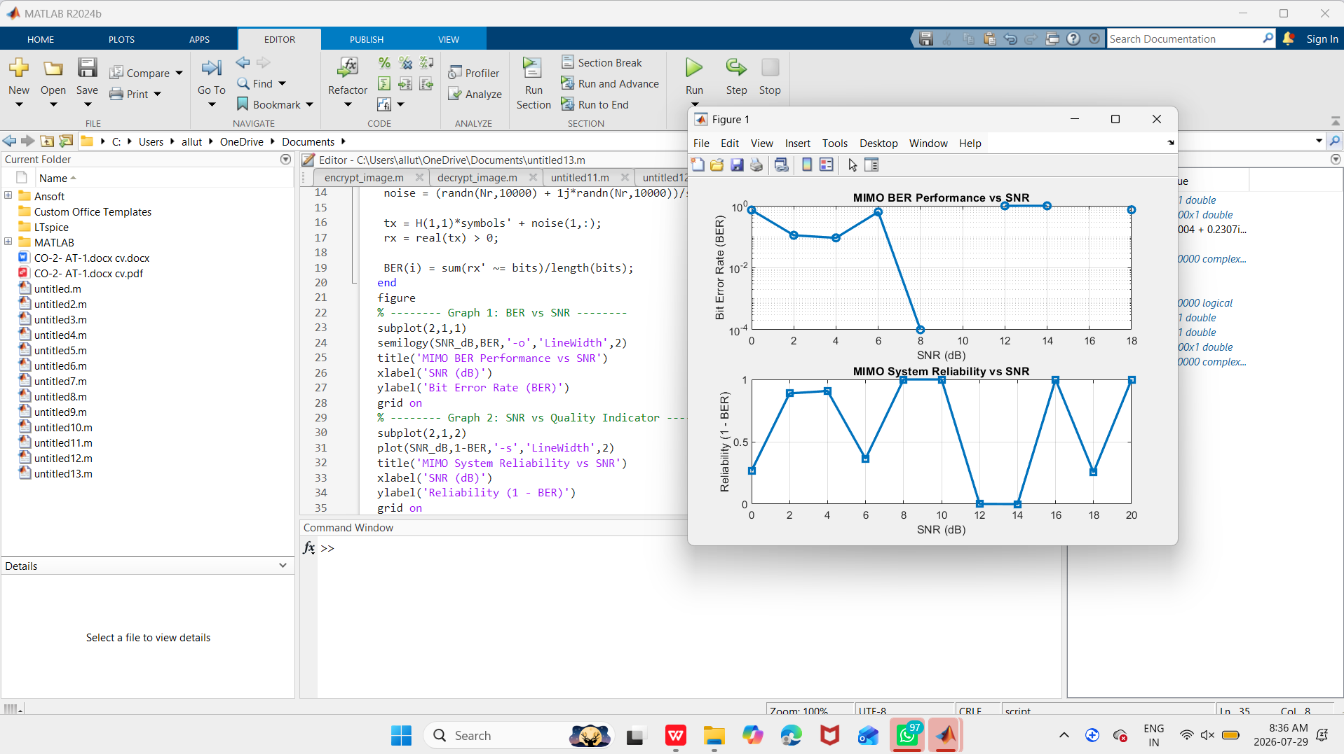

Objective 2 :
To analyze the impact of Signal-to-Noise Ratio (SNR in dB) on the reliability and quality of MIMO communication.

Objective 2 Matlab Code and Output:
clc; clear; close all;
SNR_dB = 0:2:20;
SNR = 10.^(SNR_dB/10);

Nt = 2; Nr = 2;

Reliability = zeros(1,length(SNR));
for i = 1:length(SNR)
H = (randn(Nr,Nt) + 1j*randn(Nr,Nt))/sqrt(2);
noise_power = 1/SNR(i);
Reliability(i) = 1 - exp(-SNR(i)/10);
end
figure

subplot(2,1,1)
plot(SNR_dB, Reliability, '-o', 'LineWidth', 2)
title('MIMO Reliability vs SNR')
xlabel('SNR (dB)')
ylabel('Reliability (0 to 1)')
grid on

subplot(2,1,2)
plot(SNR_dB, noise_power*ones(size(SNR_dB)), '-s', 'LineWidth', 2)
title('Noise Power Variation with SNR')
xlabel('SNR (dB)')
ylabel('Noise Power')grid on

OUTPUT:

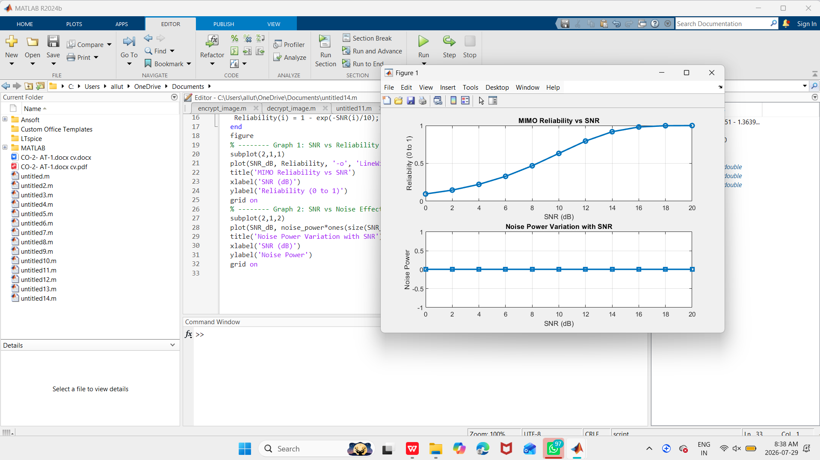

OBJECTIVE 3:

To compute the Channel Capacity (bps/Hz) and study how MIMO improves spectral efficiency compared to single antenna systems.

Objective 3 Matlab Code and Output:
clc; clear; close all;

rb_bw = 180e3;

users = 1:5;

alloc_RB = [10 12 8 15 5];

mod_eff = [2 4 6 4 2];

throughput = (alloc_RB .* rb_bw .* mod_eff) / 1e6;
disp('User Throughput (Mbps):')
disp(throughput')
figure

subplot(2,1,1)
plot(users, throughput, '-o','LineWidth',2)
title('OFDMA User Throughput')
xlabel('User Index')
ylabel('Throughput (Mbps)')
grid on

subplot(2,1,2)
plot(alloc_RB, throughput, '-s','LineWidth',2)
title('Resource Blocks vs Throughput')
xlabel('Allocated Resource Blocks')
ylabel('Throughput (Mbps)')
grid on

OUTPUT:

